**Forum:** Special Conference on Southeast and Central Asia

**Issue:** Measures to resolve territorial disputes in the East China Sea

**Student Officer:** Chae Won Park

**Position:** Chair of Special Conference

Introduction

Located in the East China Sea, the Senkaku Islands are home to abundant oil and natural gas reserves. Not only do the islands provide rich fishing grounds, they also possess a strategically significant location in the Pacific Sea. Historically, the Senkaku Islands served as maritime navigational markers and were never liable to any nation’s control. In 1895, the Senkaku Islands were claimed by Japan and have been in their control ever since. However, titling these islands as the Diaoyu Islands, China have begun to reassert claims over the region. By citing historic rights to the area, China contends to have had control over the Diaoyu Islands since the 1400s. China’s sudden change of stance initiated the 50-year dispute over these islands between China and Japan; both nations strive to get hold of the economically and strategically valuable lands.

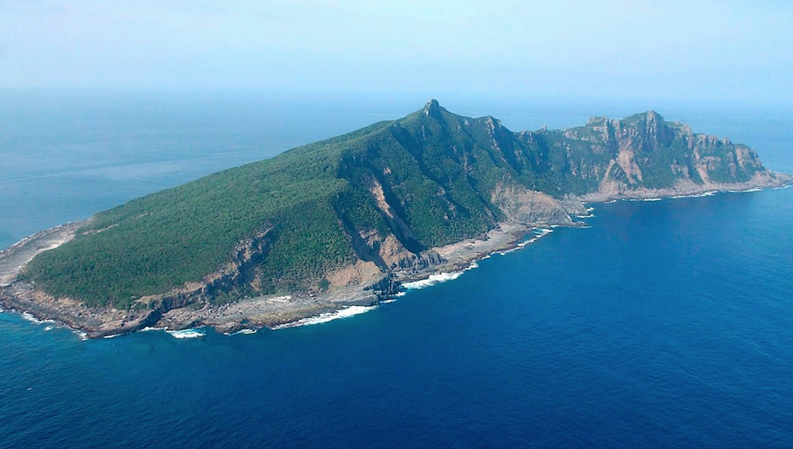The favorable location and monetary worth of the Senkaku Islands aggravate the competition between the two countries. The islands are not only near major shipping routes but are also surrounded by rich fishing areas. Since China’s acknowledgement of the merits of the Senkaku islands in the 1970s, territorial disputes in the East China Sea has not ceased. Although tension between China and Japan has been relatively moderate, the Japanese government’s recent acquisition of three prominent islands in the East China Sea has sparked public and diplomatic protests in China. The hostility stemming from the conflict between the two nations has elevated the risk of incidents in the area and will continue to threaten global peace by drawing U.S. forces into the conflict if measures to resolve the issue are not promptly taken.

***The Senkaku Islands / The Diaoyu Islands in the East China Sea***

After the Japanese government’s purchase of islands in 2012, there has been communication between China and Japan to some extent. However, tranquillity in the East China Sea did not last long. In 2013, China publicly proclaimed the establishment of a formal Air Defense Identification Zone. (ADIZ) The zone not only covered airspace over the Senkaku Islands but also overlapped with airspace already claimed by Japan, entailing all airlines flying over it to abide by rules instituted in China. Both Japan and the United States have disregarded this individual act by China. Support from the United Nations to peacefully resolve the issues at hand is urgent.

Definition of Key Terms

Senkaku/Diaoyu Islands

The Senkaku Islands, or Diaoyu Islands as the Chinese have named them, are eight uninhabited islands located in the East China Sea. They lie north-east of Taiwan, east of China, and south-west of Japan. The Senkaku/Diaoyu Islands are closer to Japan than they are to China, but they are positioned on the border of China’s continental shelf which supports China’s assertion that the Senkaku Islands are part of their territory. Presently, the disputed Senkaku Islands are under the administration of Japan.

Territorial Dispute

A territorial dispute is a discord between two or more geographical bodies over the control of land. Most territorial disputes are driven by demand for natural resources and can result in disastrous wars. The Senkaku Islands Dispute is an example of a territorial dispute.

United Nations Convention on the Law of the Sea (UNCLOS)

The United Nations Convention on the Law of the Sea (UNCLOS) was created on December 10th, 1982, to specify rights and responsibilities of nations with regard to their use of oceans. Since UNCLOS’s formation, 167 countries and the European Union have signed the treaty. Both Japan and China have reached an agreement on the fact that conforming to the United Nations Convention on the Law of the Sea (UNCLOS) is essential to resolve the present issue between them.

Air Defense Identification Zone (ADIZ)

An Air Defense Identification Zone (ADIZ) is an officially defined area of airspace above land or water, in which unknown aircrafts are subjected to be examined for identification by a sovereign nation. Not all countries enforce the installation of ADIZs. However, today, nations such as the United States, Japan, India, Norway, Pakistan, Taiwan, South Korea, People’s Republic of China (PRC), and the United Kingdom preserve this rule.

Nautical Mile

A nautical mile is defined as 1,852 meters. Based on the circumference of Earth, the unit of measurement is used for air and sea travel all around the globe. The United Nations Convention on the Law of the Sea (UNCLOS) has defined Exclusive Economic Zones (EEZs) as territorial waters reaching out 200 nautical miles from the baseline, where countries have unconditional rights to the waters, the seabed, and the natural resources that are found there.

Exclusive Economic Zone (EEZ)

An Exclusive Economic Zone (EEZ) is a sea zone that stretches out 200 nautical miles from the baseline over which a nation has unique rights in respect of study and utilization of marine resources. Both China and Japan claim that their own EEZ covers the Senkaku Island region. Unlike an Air Defense Identification Zone, an Exclusive Economic Zone requires international legal agreement among nations.

General Overview

Occupation of the Senkaku islands

Prior to Japan’s occupation of the Senkaku Islands in 1895, the area was uninhabited. After the islands were surveyed by Japan in the 1800s, they were incorporated into Japanese territory after their victory in the First Sino-Japanese War with the Qing Empire. Before 1971, no one, including the Chinese, made any claims to the territorial authority of the Senkaku Islands. Furthermore, no government of any country expressed any objection to Japanese sovereignty over the islands. However, circumstances changed when the significance of the Senkaku Islands was unveiled.

Importance of the Senkaku islands

The Senkaku Islands have great strategic and economic benefits. The islands are not only near important shipping lanes, where large amounts of international trade transit, but also close to natural resources, such as oil, gas, and mineral deposits. The location of the islands is also strategically important due to the escalating competition between China, Japan, and the United States for military supremacy in the Asian-Pacific Sea.

In the late 1960s, the Economic Commission for Asia and the Far East (ECAFE) studied the waters around the Senkaku Islands and identified potentially rich oil deposits beneath the seabed. China’s reaction to ECAFE’s announcement was swift; the nation made its first territorial claim to the islands.

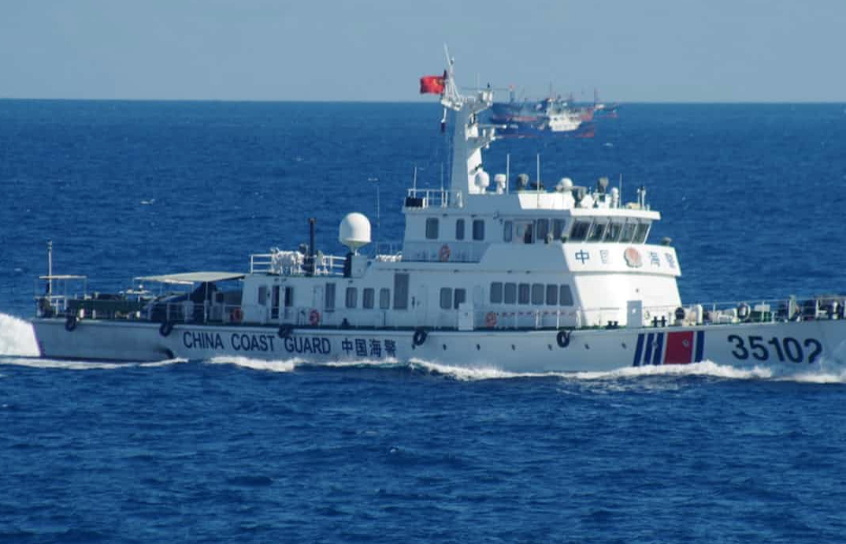The Senkaku/Diaoyu islands dispute

Prior to the scientists’ discovery of potential oil layers in the 1960s, there was absolutely no dispute over the Senkaku Islands. All of a sudden, after decades of complete indifference, China claims to have first discovered the islands and named them Diaoyu; they support their assertion with evidence that the waters surrounding the Diaoyu Islands have traditionally been Chinese fishing grounds for generations. The government of China has utilized these historical records to legitimize Chinese sovereignty and has even been sending government ships with Chinese coastguards near the disputed islets. Impertinent acts of China such as this have sparked a furious argument between Asia’s two largest economies. By refuting China’s allegation of historically administrating the islands through their surveys in 1885, the Japanese government strongly affirms that the Senkaku Islands are lucidly a congenital territory of Japan.

***A Chinese coastguard vessel approaching the Senkaku Islands***

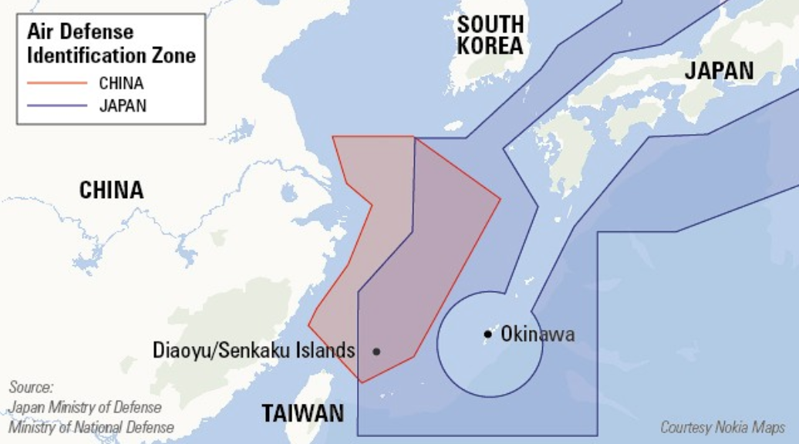Possible sources of the conflict

The Senkaku/Diaoyu Islands lie where China and Japan’s Exclusive Economic Zone (EEZ) and Air Defense Identification Zone (ADIZ) overlap. To verify their authority over the Senkaku Islands, the government of Japan purchased three of the islands from a private Japanese owner, the Kurihara family. This act of Japan in 2012 triggered an angry response from China. The following year, Chinese officials publicly proclaimed the establishment of a formal Air Defense Identification Zone. The zone covered airspace above the Senkaku as well as airspace already claimed by Japan. No issues have resulted, for both Japan and the United Nations have neglected this independent move of China.

***China and Japan’s Air Defense Identification Zones***

Chinese diplomatic and military threats

From 1978 to 2008, China made 13 militarized threats and 13 diplomatic threats against Japan. Tensions between the two nations were highest in 1996 when Japan ratified the UNCLOS. This meant that Japan would enforce its control of Japan’s EEZ, including the disputed Senkaku Islands. China accused the Japanese government of reviving militarism, restated its claim, and deployed two submarines to the islands. In April 2005, the largest anti-Japanese protests occurred all across China. The Chinese government tacitly approved the large-scale protests by sending hundreds of police to protect the protestors. Despite Japan’s requests to halt the protests, the Chinese government allowed them to continue. The protests led to violent attacks on the Japanese embassy, calling for Japan’s withdrawal from the Senkaku Islands.

UN Involvement, Relevant Resolutions, Treaties and Events

In response to escalating tension between China and Japan since 1970, the supra-partisan Diet Association for the Preservation of Territorial Integrity was founded in 2004. The Diet Association endeavors to settle the two nations’ dispute by means of creating and executing resolutions. Later that year, the Security Committee of the Lower House of the Diet Association passed a resolution on the Senkaku Islands dispute for the first time. The resolution asked for both China and Japan’s maintenance of territorial integrity, at the same time demanding a more powerful stance from Japan. Japan requested for Self-Defense Forces (SDF) troops to be placed on the Senkaku Islands to prevent invasions. Offering several more resolutions 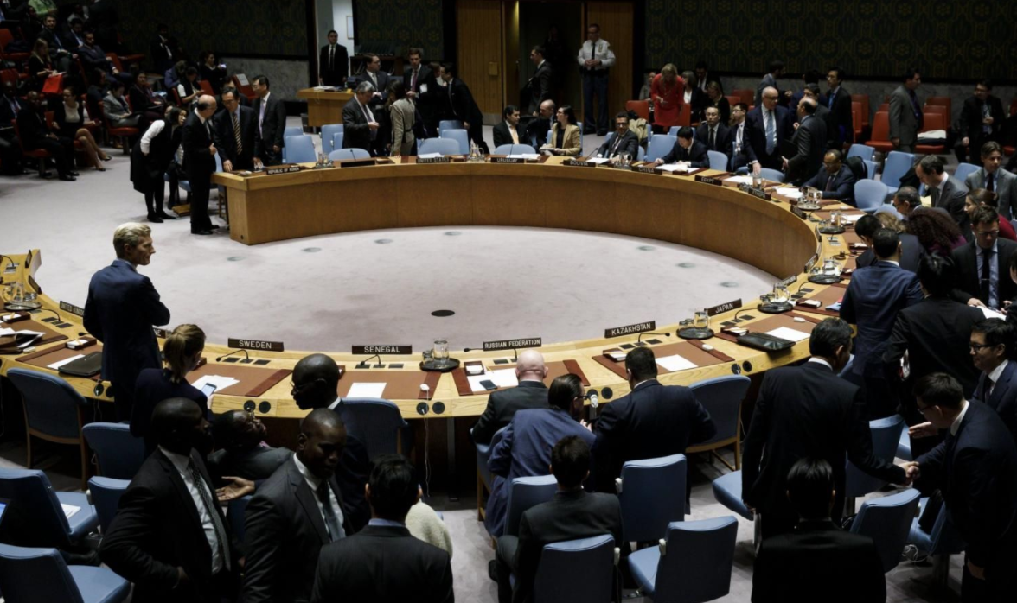and conducting conferences, the organization has undoubtedly helped in resolving the issue at hand.

Generally speaking, China’s attitude towards Japan has been fairly crude. In several UN conferences, China has displayed immature facets by using undiplomatic expressions, such as calling Japan’s investment of three islands in the East China Sea ‘a farce.’ While Japan calmly pressed China with the fact that China only wished to alter the status quo of the Senkaku Islands after they have ascertained the islands’ value, China expressed frustration and continued to utilize indecent diction without hesitation.

The scene at the United Nations General Assembly was not much different. Japan’s Deputy United Nations Ambassador requested for cordial resolutions under international laws. China maintained its aggressive behavior and went as far as labeling Japan’s claim ‘gangster logic.’ Since the 1970s up to now, China has ceaselessly published articles on Japan’s violence against themselves.

Both China and Japan rely on the United Nation Convention on the Law of the Sea (UNCLOS). China builds its claim on the UNCLOS principle of the natural prolongation of the continental shelf, while Japan builds its claim on the UNCLOS’s limit of EEZs and the UNCLOS principles of equidistance and equitable solution. To China, the disputed lands lie across the median line between China and Japan; to Japan, they are located where the two countries’ EEZs overlap.

Timeline of Events

|  |  |
| --- | --- |
| **Date** | **Description of event** |
| 1895 | The Japanese Government annexes the formerly independent Senkaku/Diaoyu Islands after the First Sino-Japanese War in early 1895 |
| 1970  December 10th, 1982 | China declares that the Diaoyu Islands belong to them at a Press Conference  The United Nations Convention on the Law of the Sea (UNCLOS) is founded to specify rights and responsibilities of nations with regard to their use of oceans |
| March 30th, 2004  September 11th, 2012  November 23rd, 2013 | The Diet Association passes a resolution concerning the Senkaku Islands for the first time, successfully persuading the two nations to retain territorial integrity by establishing the supra-partisan Diet Association for the Preservation of Territorial Integrity in 2004  The Japanese Government purchases the Minami-Kojima, Kita-Kojima, and Uotsuri Islands from the Kurihara family for ¥2.05 billion  China announces the establishment of East China Sea ADIZ, but their move is dismissed by both the Japanese government and the UN |

Possible Solutions

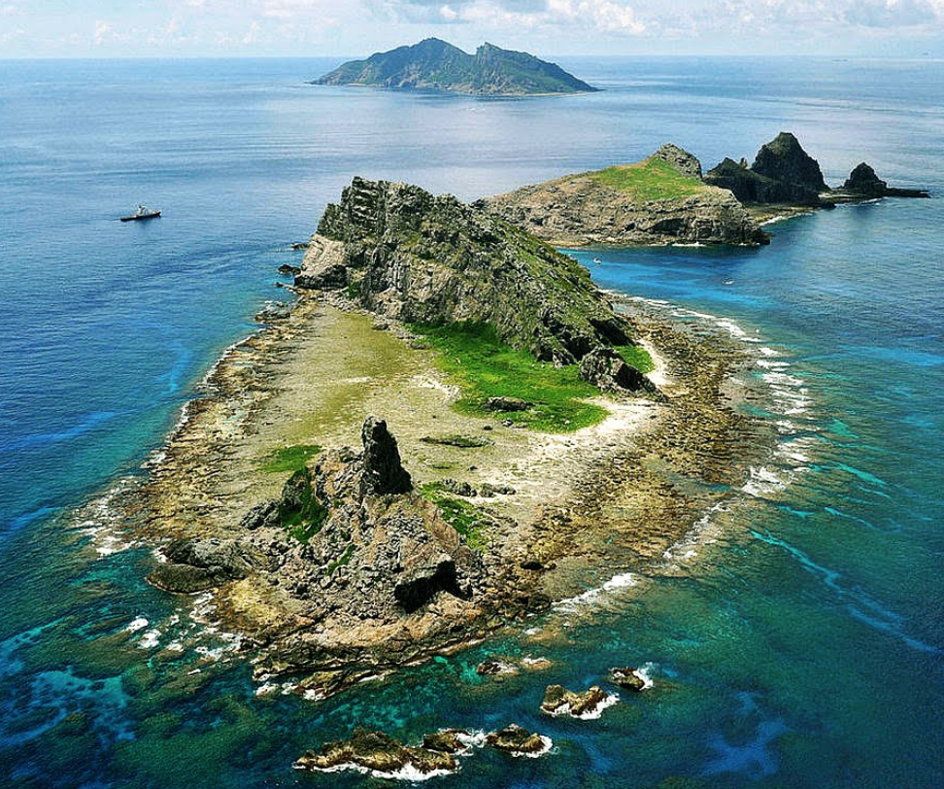Since both countries claim to be the possessor of the Senkaku/Diaoyu Islands, finding a solution to settle the intense quarrel is difficult. However, with the cooperation of China and Japan, it is not impossible.

A possible solution to resolve the Senkaku/Diaoyu Islands Dispute would include six points. First, each side must agree not to challenge the other party’s right to maintain its respective claims to full sovereignty over all the islands. Both parties are aware of the fact that their relationship has been tense for the past few decades. In 2014, China and Japan had agreed to gradually resume political and diplomatic dialogues. Since both sides have acknowledged that everyone wishes to put an end to tensions between China and Japan, hopes of agreement between them are high. Second, China must agree to accept that Japan will legally continue to have administrative rights over the Senkaku/Diaoyu islands. Third, Japan must accept that use of the islands will be delegated to an oversight board, with equal numbers of Japanese and Chinese members, making any decisions on the use of the islands by consensus. In other words, Japan’s capital city of Tokyo must agree to share all administrative duties and rights with China. Fourth, patrols around the Senkaku/Diaoyu Islands by any ships or planes from either side must end. All patrolling within the 12-mile zone bordering the islands would be done in partnership. The Senkaku/Diaoyu Islands must be used solely for nonmilitary purposes such as ecological tourism, with all such activities comprehensively regulated by the oversight board. Last but not least, both sides must agree that they will not open up any new territorial disputes with the other over any land or sea formations anywhere in the 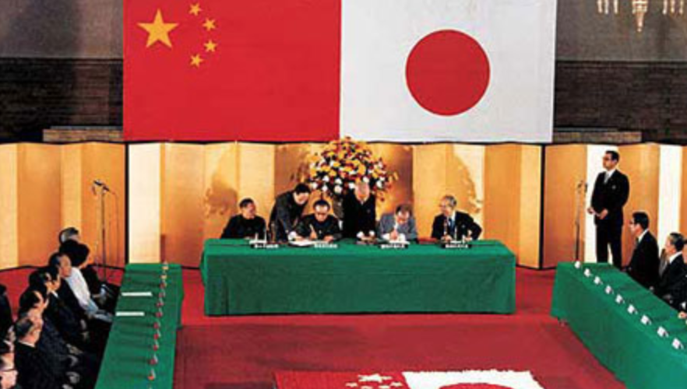western Pacific Sea.

***Minami-Kojima, Kita-Kojima, and Uotsuri Islands***

***Sino-Japanese treaty of peace and friendship in 1978***

Only resolutions containing the items stated above can work, because they ask for flexibility from each side simultaneously, yet they also clearly uphold what have been the rudimentary demands of both. At a minimum, the two parties should seek a freeze. Alternatively, or subsequently, they should find a permanent resolution to settle the problem. If all fail, an academic debate involving the Chinese government, the Japanese government, and the United Nations about how to solve this dispute must take place rather than simply hoping that it does not turn into a serious crisis.

Like so many other disputes, it does not matter so much which part is right on the Senkaku Islands, but that the issue is resolved in a peaceful manner. This will only be done through proposals of plausible solutions from the United Nations. Doing so will require an act of integrity from both Japan and China; we must make both nations recognize the fact that the Senkaku Islands Dispute will not be resolved unless both parties maintain honest attitudes. Building trust seems to be a fundamental step in resolving the current dispute between China and Japan.

Bibliography

Das, Shaheli. “Why is China escalating tensions in the East China Sea?” *APPS* Policy Forum, 22 Sep. 2016. Web. 07 Nov. 2017. <<https://www.policyforum.net/china-escalating-tensions-east-china-sea/>>

Hashimoto, Akikazu. “A framework for resolving Japan-China dispute over islands.” *Opinion* Los Angeles Times, 01 Dec. 2014. Web. 20 Nov. 2017. <<http://www.latimes.com/opinion/op-ed/la-oe-ohanlon-china-japan-senkaku-diaoyu-islands-20141130-story.html>>

Rosen, Mark. “Fixing the Senkaku/Diaoyu Problem One and For All.” *Features* The Diplomat, 19 Dec. 2014. Web. 20 Nov. 2017. <<https://thediplomat.com/2014/12/fixing-the-senkakudiaoyu-problem-once-and-for-all/>>

Hunt, Katie. “East China Sea: How an uninhabited island chain splits Japan and China.” *Regions* CNN, 07 Feb. 2017. Web. 07 Nov. 2017. <<http://edition.cnn.com/2017/02/07/asia/east-china-sea-senkaku-diaoyu-islands-explainer/index.html>>

Drifte, Reinhard. “The Japan-China Confrontation Over the Senkaku/Diaoyu Islands – Between “shelving” and “dispute escalation”.” *Japan Focus* The Asia-Pacific Journal, 27 July 2014. Web. 07 Nov. 2017. <<http://apjjf.org/2014/12/30/Reinhard-Drifte/4154/article.html>>

Z. D. “Who really owns the Senkaku Islands?” *The Economist Explains* The Economist, 03 Dec. 2013. Web. 20 Nov. 2017. <<https://www.economist.com/blogs/economist-explains/2013/12/economist-explains-1>>

Welch, David. “What’s an ADIZ?” *East Asia China* Foreign Affairs, 09 Dec. 2013. Web. 10 Dec. 2017. <<https://www.foreignaffairs.com/articles/east-asia/2013-12-09/whats-adiz>>

“How uninhabited islands sourced China-Japan ties.” *Asia* BBC, 10 Nov. 2014. Web. 07 Nov. 2017. <<http://www.bbc.com/news/world-asia-pacific-11341139>>

“Japan warns China of deteriorating relations over Senkaku Islands.” *Senkaku Islands* theGuardian, 09 August. 2016. Web. 10 Dec. 2017. <<https://www.theguardian.com/world/2016/aug/09/japan-warns-china-of-deteriorating-relations-over-senkaku-islands>>

Holland, Tom. “There’s only one way to solve the Diaoyu/Senkaku dispute.” *Diaoyu Islands* Opinion, 10 July. 2013. Web. 20 Nov. 2017. <<http://www.scmp.com/business/article/1279071/theres-only-one-way-solve-diaoyusenkaku-dispute>>

Turton, Michael. “Constructing China’s Claims to the Senkaku.” *The Editor* The Diplomat, 06 Nov. 2013. Web. 10 Dec. 2017. <<https://thediplomat.com/2013/11/constructing-chinas-claims-to-the-senkaku/>>

Wiegand, Krista. “China's Strategy in the Senkaku/Diaoyu Islands Dispute: Issue Linkage and Coercive Diplomacy.” *Asian Security* Taylor & Francis Online, 28 May 2009. Web. 10 Dec. 2017. <<http://www.tandfonline.com/doi/full/10.1080/14799850902886617?src=recsys>>